

# “A CRM APPLICATION FOR MANAGING LOAN APP AND FRADULENT PREVENTION”

# 

**NAAN MUDHALVAN PROJECT REPORT**

***Submitted by***

**NARESH KUMAR G (620120104068)**

**SHYAMBABU S (620120104090)**

**SURYS S (620120104315)**

**YUVARAJ S (620120104320)**

***in partial fulfilment for the award of the degree of***

# Bachelor of Engineering

***in***

# Computer Science and Engineering

**AVS Engineering College,**

**SALEM – 636003.**

# ANNA UNIVERSITY::CHENNAI 600025

**BONAFIDE CERTIFICATE**

## Certified that this the project report titled “A CRM APPLICATION FOR MANAGING LOAN APP AND FRADULENT PREVENTION” is the bonafied work of “NARESH KUMAR G (620120104068), SHYAMBABU S (620120104090), SURYS S (620120104315), YUVARAJ S (620120104320)” who carried out the project work under my supervision.

|  |  |
| --- | --- |
| **SIGNATURE**  **Prof. S. DHAMODARAN M.E.,**  **ASSISTANT PROFESSOR**  **FACULTY MENTOR**  Department of CSE,  AVS Engineering College, Salem-636003. | **SIGNATURE**  **Dr.R.VISHWANATHAN M.E., Ph.D.,**  **ASSISTANT PROFESSOR**  **SPOC FACULTY**  Department of CSE,  AVS Engineering College, Salem-636003. |
|  |  |

## SPOC HEAD OF THE DEPARTMENT

### **ACKNOWLEDGEMENT**

I thank my god for providing me with everything that I required in completing this project.

My most sincere salutations go to ANNA UNIVERSITY that gave me an opportunity to have sound base of Computer Science and Engineering.

I acknowledge with deep sense of gratitude to our Chairman Shri.**K.KAILASAM**, secretary Mr.**K.RAJAVINAYAKAM M.B.A**., and our Correspondent Mr.**K.SENTHIL KUMAR** **B.Tech**., for providing all the necessary facilities to do this project.

I thank our Vice Principal’s **Dr.R.VISHWANATHAN M.E., Ph.D.,** and **Dr.D.R.JOSHUA M.E., Ph.D.,** for his timely advice and encouragement.

I offer my sincere thanks to **Dr.M.VILASHINI M.E., Ph.D.,** Dean and **Prof .V.MEENA M.E.,** Head of The Department, for giving his constant support and motivation.

I am indebted to my guide **Prof. S. DHAMODARAN M.E.,** Assistant professor for my constant guidance and encouragement throughout the project work. I Also express my thanks to all faculty members and friends for their support towards the successful; completion of the project.

**TABLE OF CONTENTS**

|  |  |  |
| --- | --- | --- |
| **Chapter No** | **Title** | **Page No** |
| **1.** | LIST OF FIGURESLIST OF ABBREVIATIONSPROJECT SPECIFICATIONProject Goal  * 1. Project Scope   2. Problem Statement Definition   3. Empathy Map Canvas   4. Ideation & Brainstorming   5. Proposed Solution   6. Functional & Technical Requirements   7. Project Road Map | 05  06  07  08  09  10  11  14  16  19 |
| **2.** | **PREPARATION DATA MODELING**  2.1 Salesforce Developer Org  2.2 Custom Object Creation & Tabs  2.3 Lightning App | 23  25  31 |
| **3.** | **USERS AND DATA SECURITY** |  |
|  | 3.1 Customize User Interface | 32 |
| **4.** | **AUTOMATION**  4.1 Working Process And User Adaption  4.2 Apex  4.3 Apex Scheduler | 33  36  38 |
| **5.** | **REPORTS AND DASHBOARDS**  5.1 Reports  5.2 Dashboards | 40  43 |
| **6.**  **7.** | **CONCLUSION**  **PROJECT DEMONSTRATION**  Github & Project Video Demo Link | 44  45 |

# LIST OF FIGURES

|  |  |  |
| --- | --- | --- |
| **Figure No** | **Name Of Figure** | **Page No** |
| 1.8.1 | Data Flow Diagram | 19 |
| 1.8.2 | Technical Architecture | 20 |

# 

**LIST OF ABBREVIATION**

|  |  |
| --- | --- |
| CRM | Customer Relationship Management |
| APP | Application |
| FPM | Fraud Prevention Module |
| LAM | Loan Application Management |
| UI | User Interface |
| API | Application Programming Interface |
| DB | Database |
| KYC | Know Your Customer |
| IDV | Identity Verification |
| PII | Personally Identifiable Information |
| GUI | Graphical User Interface |

# CHAPTER-1 PROJECT SPECIFICATION

* 1. **Project Goal**

The central objective of this project is to develop a comprehensive CRM (Customer Relationship Management) application that caters to the specific requirements of loan application management and robust fraud prevention. Our overarching goal is to streamline and optimize the loan application process, ensuring efficiency, accuracy, and security, while simultaneously mitigating the risks associated with fraudulent activities. This all-encompassing system aims to offer a seamless experience for loan applicants, facilitating application submissions, status tracking, and document uploads. Through the integration of advanced fraud prevention techniques, including anti-money laundering (AML) checks, identity verification, OCR-based document validation, credit scoring, and machine learning-driven fraud detection, we aspire to safeguard the institution against fraudulent activities effectively.

In addition, this project will enhance customer relationship management by centralizing customer information and fostering improved communication, leading to more personalized and efficient services. Moreover, compliance with regulatory requirements, data security, scalability, and user support are pivotal aspects of our project. By establishing measurable key performance indicators (KPIs) and regularly assessing the impact, our goal is to deliver a system that optimizes loan application processes, prevents fraud, ensures compliance, and ultimately enhances customer satisfaction and risk mitigation.

# Project Scope

The project scope in Salesforce should encompass your specific objectives and requirements within this powerful CRM ecosystem. Define the primary objectives, such as optimizing sales processes, automating marketing campaigns, or improving customer support. Detail the user requirements, outlining how various Salesforce users will engage with the platform and the specific tasks they need to accomplish. Specify the data management aspects, including which Salesforce objects (like leads, contacts, accounts, and opportunities) will be used and any data migration requirements. Customization within Salesforce should be addressed, detailing custom fields, objects, page layouts, and workflows tailored to your organization's unique needs.

Consider any necessary integrations with third-party applications or systems, explaining the data flows and the purpose of each integration. Establish your reporting and analytics requirements, and discuss user training and adoption strategies to ensure a smooth transition. Ensure data security and privacy measures are in place, addressing compliance with data protection regulations if necessary. Lastly, set clear boundaries by stating any functionalities or requirements that fall outside the project scope to manage expectations effectively. By comprehensively defining the scope within Salesforce, you will provide a solid foundation for a successful project implementation that aligns with your business objectives.

# Problem Statement Definition

In the context of implementing a Salesforce-based CRM solution for loan application management and fraud prevention, several critical challenges and issues are evident. The existing manual and disparate systems for handling loan applications have led to inefficiencies, data discrepancies, and prolonged processing times. Furthermore, the absence of robust fraud prevention mechanisms has exposed our institution to an elevated risk of financial losses and reputational damage due to fraudulent activities.

The primary problems can be summarized as follows:

1. Inefficient Loan Application Management: The current loan application process relies heavily on manual data entry and lacks a streamlined, automated workflow. This inefficiency results in prolonged application processing times and hinders our ability to serve customers promptly.

2. Fraud Vulnerability: The absence of advanced fraud prevention measures exposes us to significant risks, including identity theft, money laundering, and false documentation. These risks threaten the integrity of our institution and can lead to substantial financial losses.

3. Data Inconsistencies: Multiple data sources and systems have led to inconsistencies and inaccuracies in customer information. This not only affects decision-making but also hampers our ability to offer personalized and efficient services.

4. Regulatory Compliance: The absence of a unified system for tracking compliance with regulatory requirements, such as Anti-Money Laundering (AML) and data protection laws, has the potential to result in non-compliance issues and legal consequences.

5. Customer Experience: The current disjointed systems undermine the overall customer experience. Delayed responses, manual document submissions, and lack of transparency can negatively impact customer satisfaction.

* 1. **Empathy Map Canvas**

An empathy map is a simple, easy-to-digest visual that captures knowledge about a

user’s behavior and attitudes.

It is a useful tool to helps teams better understand their users. Creating an effective solution requires understanding the true problem and the person who is experiencing it. The exercise of creating the map helps participants consider things from the user’s perspective along with his or her goals and challenges.

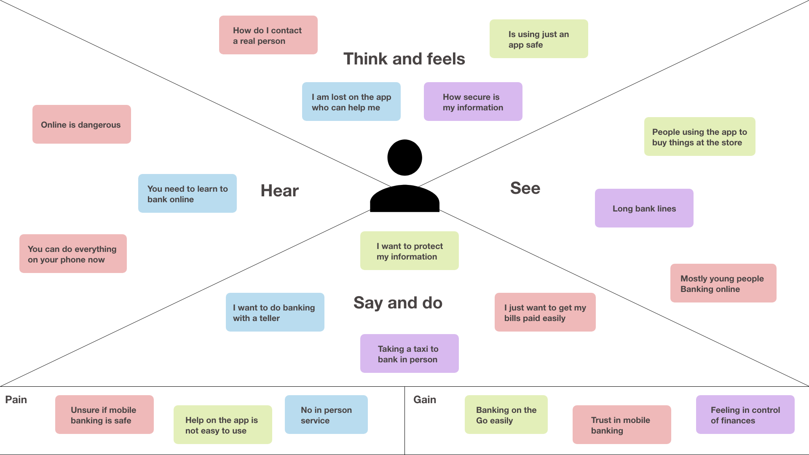

# Ideation & Brainstorming

Brainstorming provides a free and open environment that encourages everyone within a team to participate in the creative thinking process that leads to problem solving.

Prioritizing volume over value, out-of-the-box ideas are welcome and built upon, and all participants are encouraged to collaborate, helping each other develop a rich amount of creative solutions.

## Step-1: Team Gathering, Collaboration and Select the Problem Statement:

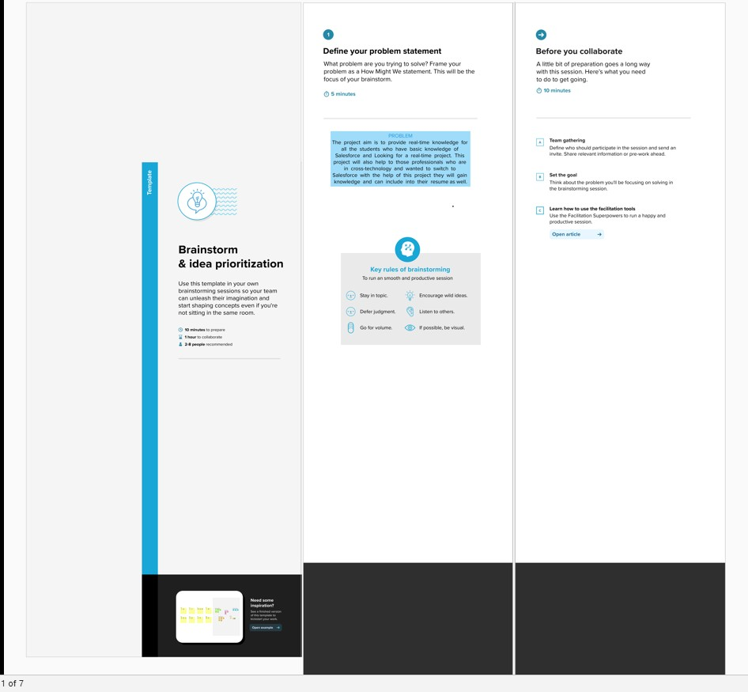

**Step-2: Brainstorm, Idea Listing and Grouping:**

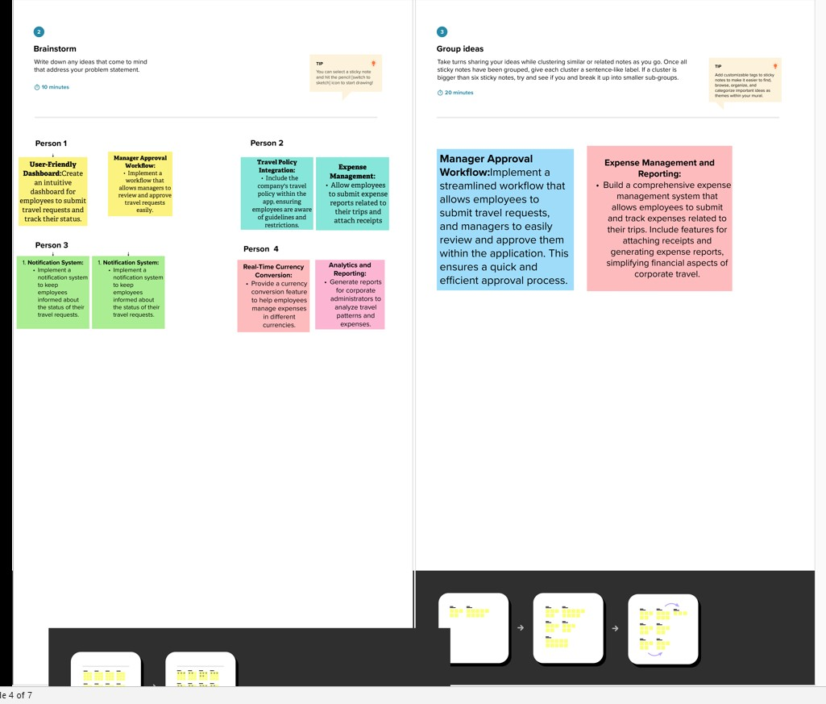

**Step-3: Idea Prioritization:**

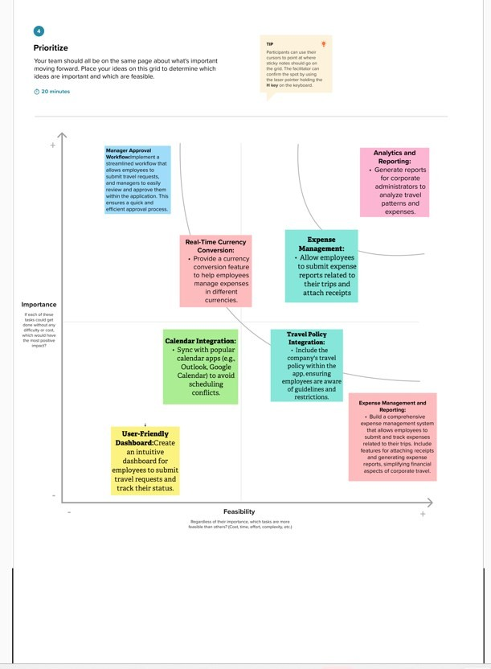

# 1.6 Proposed Solution

|  |  |  |
| --- | --- | --- |
| **S. No** | **Parameter** | **Description** |
| 1. | Problem Statement (Problem to be solved) | In the context of implementing a Salesforce-based CRM solution for loan application management and fraud prevention, several critical challenges and issues are evident. The existing manual and disparate systems for handling loan applications have led to inefficiencies, data discrepancies, and prolonged processing times. Furthermore, the absence of robust fraud prevention mechanisms has exposed our institution to an elevated risk of financial losses and reputational damage due to fraudulent activities. |
| 2. | Idea / Solution description | The central objective of this project is to develop a comprehensive CRM (Customer Relationship Management) application that caters to the specific requirements of loan application management and robust fraud prevention. Our overarching goal is to streamline and optimize the loan application process, ensuring efficiency, accuracy, and security, while simultaneously mitigating the risks associated with fraudulent activities. This all-encompassing system aims to offer a seamless experience for loan applicants, facilitating application submissions, status tracking, and document uploads. Through the integration of advanced fraud prevention techniques, including anti-money laundering (AML) checks, identity verification, OCR-based document validation, credit scoring, and machine learning-driven fraud detection, we aspire to safeguard the institution against fraudulent activities effectively |

|  |  |  |
| --- | --- | --- |
| 3. | Novelty / Uniqueness | The novelty of this CRM application lies in its fusion of cutting-edge technology, including AI-driven fraud prevention and real-time credit scoring, with the robust capabilities of Salesforce. This unique blend offers a comprehensive solution for streamlined loan management, superior customer experiences, and advanced security within a single, integrated platform. |
| 4. | Social Impact / Customer Satisfaction | The CRM application will positively impact society by simplifying loan processes and reducing fraud, making loans more accessible and secure. Enhanced customer satisfaction is achieved through seamless interactions, faster approvals, and personalized services, fostering financial well-being and trust among customers. This, in turn, contributes to a stronger, more financially inclusive community. |

* 1. **Functional & Technical Requirements**

## Functional Requirements

|  |  |  |
| --- | --- | --- |
| **FR**  **No.** | **Functional Requirement**  **(Epic)** | **Sub Requirement (Story / Sub-Task)** |
| FR-1 | User Authentication and Access Control | **User Registration:** Allow employees to register and log into the system.  **User Roles:** Define roles (employees, managers, travel administrators) with different permissions. **User Profiles:** Capture and manage user profiles,  including contact details. |
| FR-2 | Loan Application Submission | **Document Upload and Verification**: Users and applicants should be able to upload documents, and the system should verify their authenticity using OCR and other methods.  **Application Status Tracking:** Users and applicants should be able to track the status of loan applications in real time. |
| FR-3 | Approval workflow | **Workflow Automation:** Implement an automated approval process with defined workflows.  **Manager Assignment:** Automatically route requests to the appropriate manager based on criteria like department or project.  **Notifications:** Send notifications to managers and employees at various stages of the approval process. **Delegation**: Allow managers to delegate their  approval authority when they are unavailable. |
| FR-4 | Approval Management | **Manager Dashboard**: Provide managers with a dashboard to view and manage pending travel requests.  **Request Review:** Allow managers to review travel details, expense estimates, and supporting documents.  **Approval/Rejection:** Enable managers to approve or reject requests with comments.  **Escalation:** Implement escalation processes for  unattended requests or those exceeding certain thresholds |

|  |  |  |  |
| --- | --- | --- | --- |
| FR-5 | Fraud Detection and Prevention | **Fraud Detection**: The system should continuously monitor for fraudulent activities, including identity theft, money laundering, and false documentation. |  |
| FR-6 | Reporting and Analytics | **Reporting Tools:** Develop custom reports and dashboards to monitor travel request status and expenses.  **Analytics:** Implement data analytics for insights into travel patterns, expenses, and approval efficiency.  **Export:** Allow users to export reports for offline  use or sharing | |

* + 1. **Technical Requirements**

|  |  |  |
| --- | --- | --- |
| **TR**  **No.** | **Technical Requirement** | **Description** |
| TR-1 | Salesforce Environment | Utilize Salesforce's Enterprise or Unlimited edition to ensure scalability and access to  advanced features. |
| TR-2 | Development language | Develop using Salesforce's proprietary  programming language, Apex, for server- side logic. |
| TR-3 | Database | Utilize a robust and scalable database system for storing customer data, loan application information, and transaction records. Salesforce provides its database services. |
| TR-4 | Integration | * Use REST and SOAP APIs for integration with external systems, such as finance and expense management tools. * Implement Single Sign-On (SSO)   solutions for seamless and secure access. |
| TR-5 | Customization | Allow administrators to customize and configure the application, including approval workflows,  fields, and user profiles. |
| TR-6 | Mobile Accessibility | * Ensure that the application is accessible via the Salesforce mobile app for on-the- go request submission and tracking. * Develop a custom mobile app using Salesforce Mobile SDK for more tailored   mobile functionality. |

# Project Road Map

## Data Flow Diagram

A Data Flow Diagram (DFD) is a traditional visual representation of the information flows within a system. A neat and clear DFD can depict the right amount of the system requirement graphically. It shows how data enters and leaves the system, what changes the information, and where data is stored.

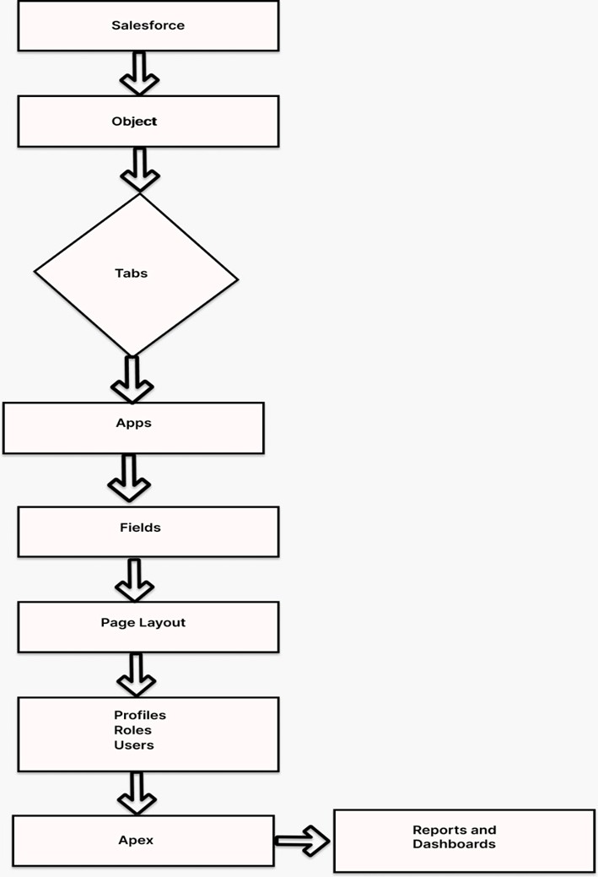

## Technical Archictecture

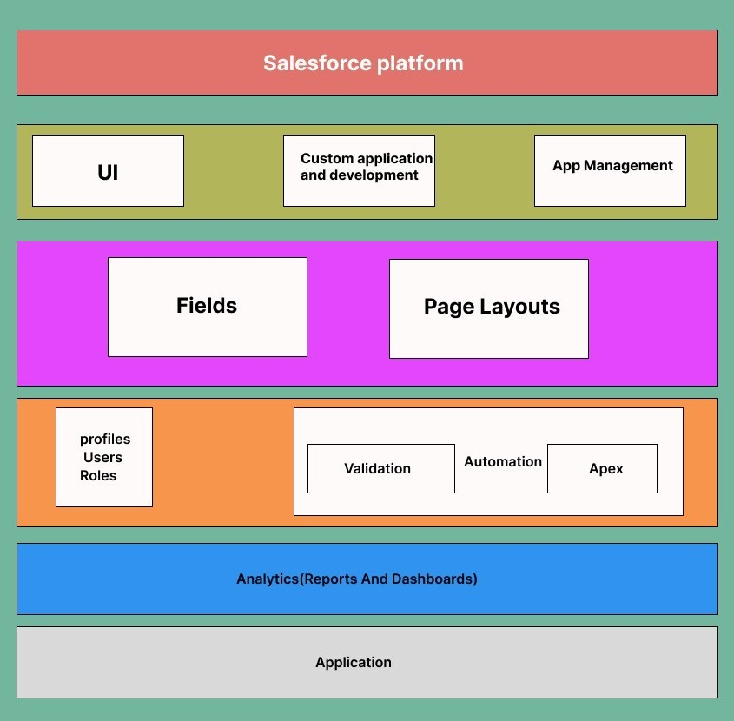

**TABLE-1: Component and Technologies:**

|  |  |  |  |
| --- | --- | --- | --- |
| **S.No** | **Component** | **Description** | **Technology** |
| 1. | User Interface | **Lightning Components**: Use Salesforce Lightning components to design the user interface for employees, managers, and administrators.  **Custom Pages:** Create custom Visualforce  pages for more tailored and complex UI elements | Salesforce |
| 2**.** | Data Model | **Custom Objects:** Define custom objects in Salesforce to represent entities like travel requests, expenses, and approvals. **Master-Detail and Lookup Relationships:** Establish relationships between objects to maintain data integrity.  Custom Fields: Create custom fields to capture specific information, such as travel dates, expenses, and approval  status. | Salesforce |

|  |  |  |  |
| --- | --- | --- | --- |
| 3. | Workflow Automation | **Approval Processes:** Implement Salesforce Approval Processes to automate and streamline the travel request approval workflow.  **Process Builder and Flows:** Use Process Builder and Flows to automate routine  tasks and send notifications. | Salesforce |
| 4. | Reporting and Analytics | **Custom Reports:** Create custom reports to track travel request status,  expenses, and other relevant metrics. | Salesforce |
| 5. | Security | **Role-Based Access Control (RBAC):** Configure RBAC to control who can access and modify data.  **Data Encryption:** Encrypt sensitive data both in transit and at rest.  **Audit Trails:** Maintain audit trails to log user activities for security and compliance  purposes. | Salesforce |
| 6. | Salesforce Development | **Apex:** Use Salesforce's proprietary programming language, Apex, for server-side logic and data manipulation.  **Visualforce:** Develop custom user interfaces with Visualforce pages and components.  **Lightning Web Components:** Create modern, component-based UIs using Lightning Web Components for a more responsive and dynamic  user experience | Salesforce |

**Table-2: Application Characteristics:**

|  |  |  |  |
| --- | --- | --- | --- |
| **S. No** | **Characteristics** | **Description** | **Technology** |
| 1. | Responsive Design | Implement responsive design to adapt to various screen sizes, ensuring a consistent and visually pleasing user  experience. | Salesforce |
| 2**.** | Accessibility | Ensure that the application is accessible via multiple devices and browsers, catering to users on desktops, tablets, and mobile devices. This accessibility is crucial for users who need to make or approve travel  requests while on the go. | Salesforce |
| 3. | User- friendly | The application should have an intuitive and user-friendly interface to make it easy for employees, managers, and administrators to navigate and use  the system without extensive training. | Salesforce |
| 4. | Scalability | The application should be able to scale with the growing number of users and data, accommodating increasing demands without  significant performance degradation. | Salesforce |
| 5. | Performance | Ensure the application's performance meets or exceeds user expectations, with rapid response times for actions such as submitting requests or generating reports. | Salesforce |
| 6. | Reporting and Analytics | Enable users to generate custom reports and access analytics tools to gain insights into travel patterns, expenses, and approval efficiency. | Salesforce |

# CHAPTER-2 PREPARATION DATA MODELING

* 1. **Salesforce Developer Org**

In Salesforce, a Developer Sign Up or Developer Edition is a special type of Salesforce environment that is primarily used for development, testing, and learning purposes.

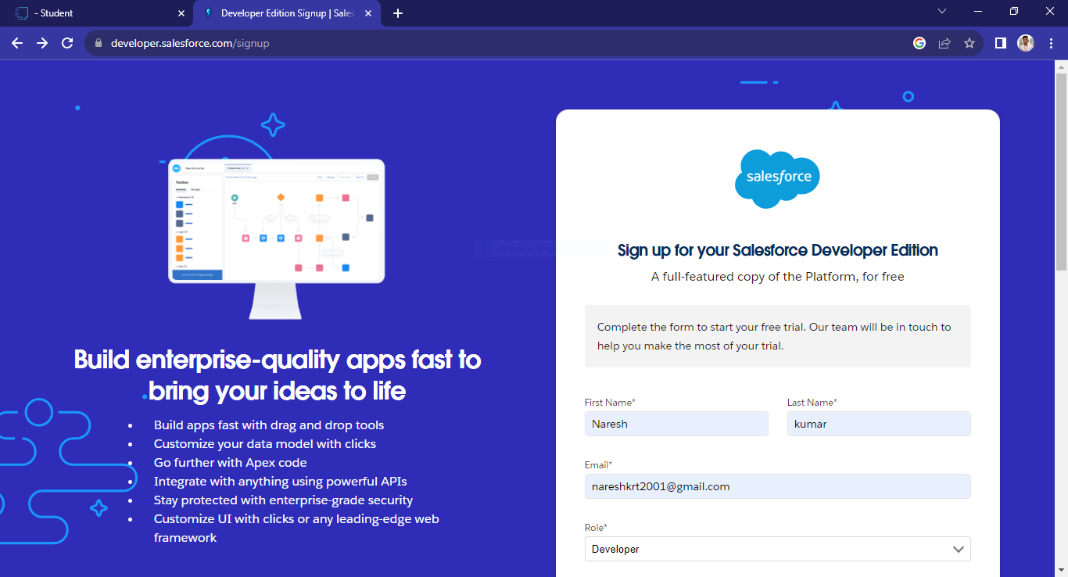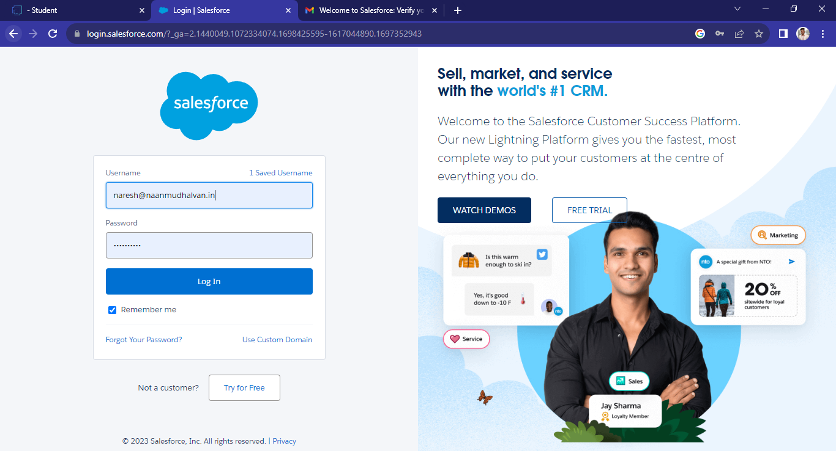

# Account Activation

Activation tracks information about devices from which users have verified their identity.

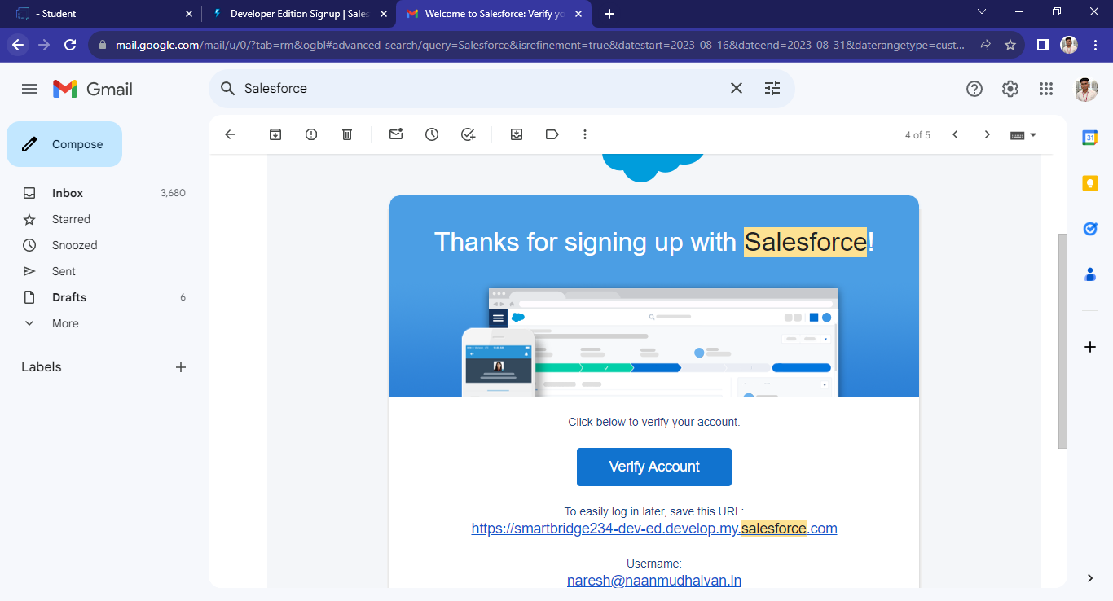

# Custom Object Creation & Tabs

**Custom Object Creation**

Objects are containers for your information, but they also give you special functionality.

Custom objects are create to store information that’s specific to your company or industry. Custom Objects in A CRM Application For Managing Loan App And Fraudulent Prevention. 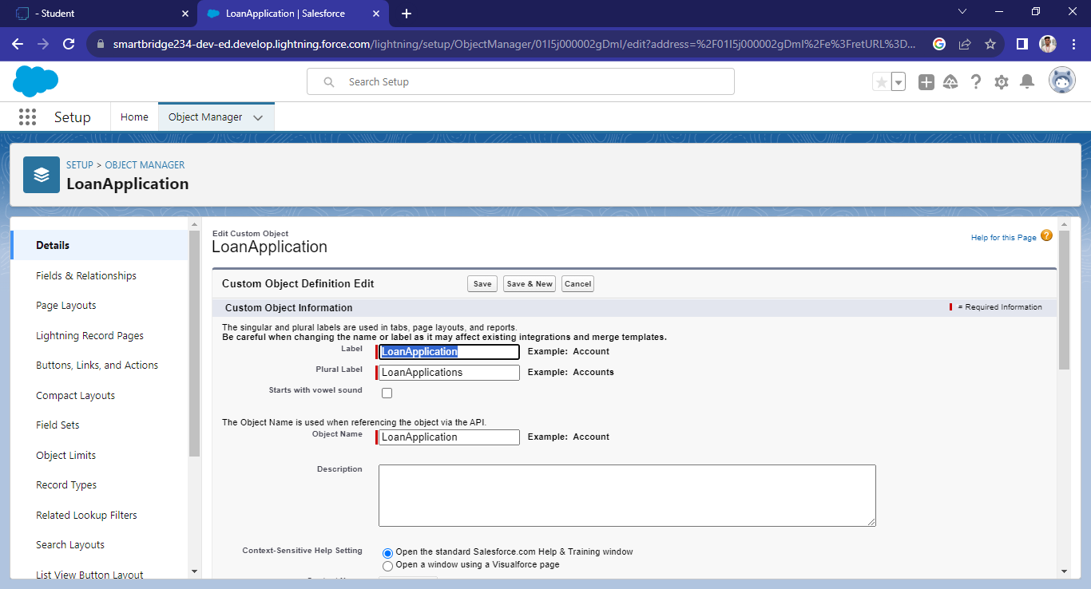

## Fields in Loan Application Object

## 

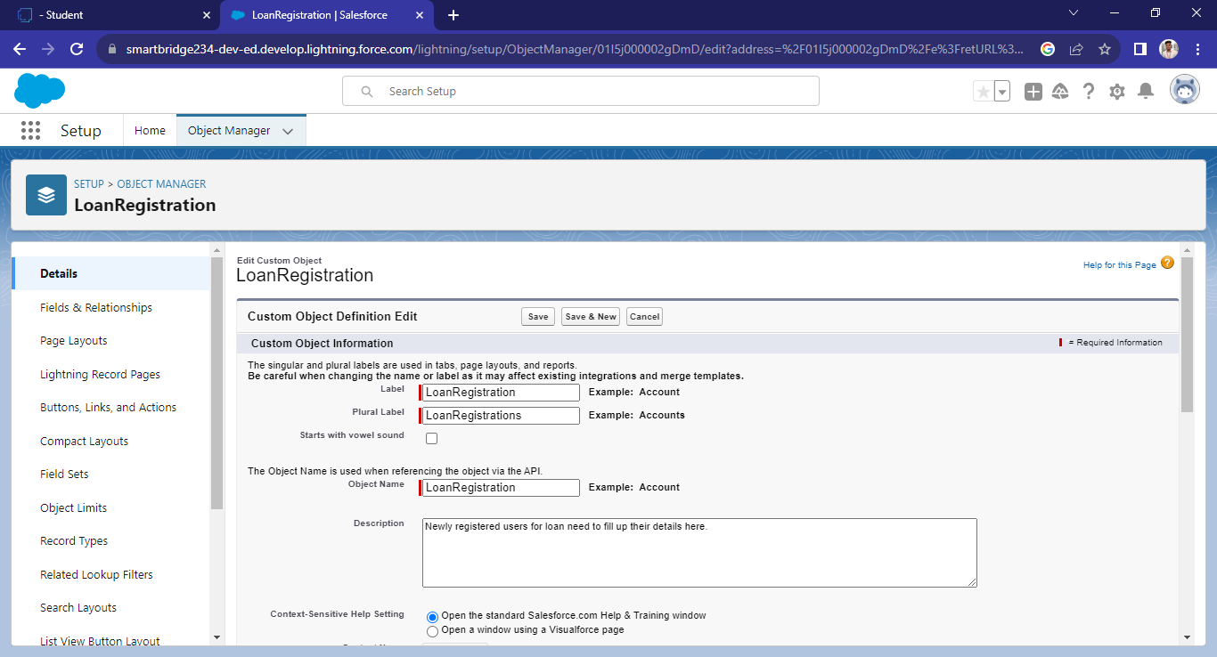

## Fields in Loan Registration Object

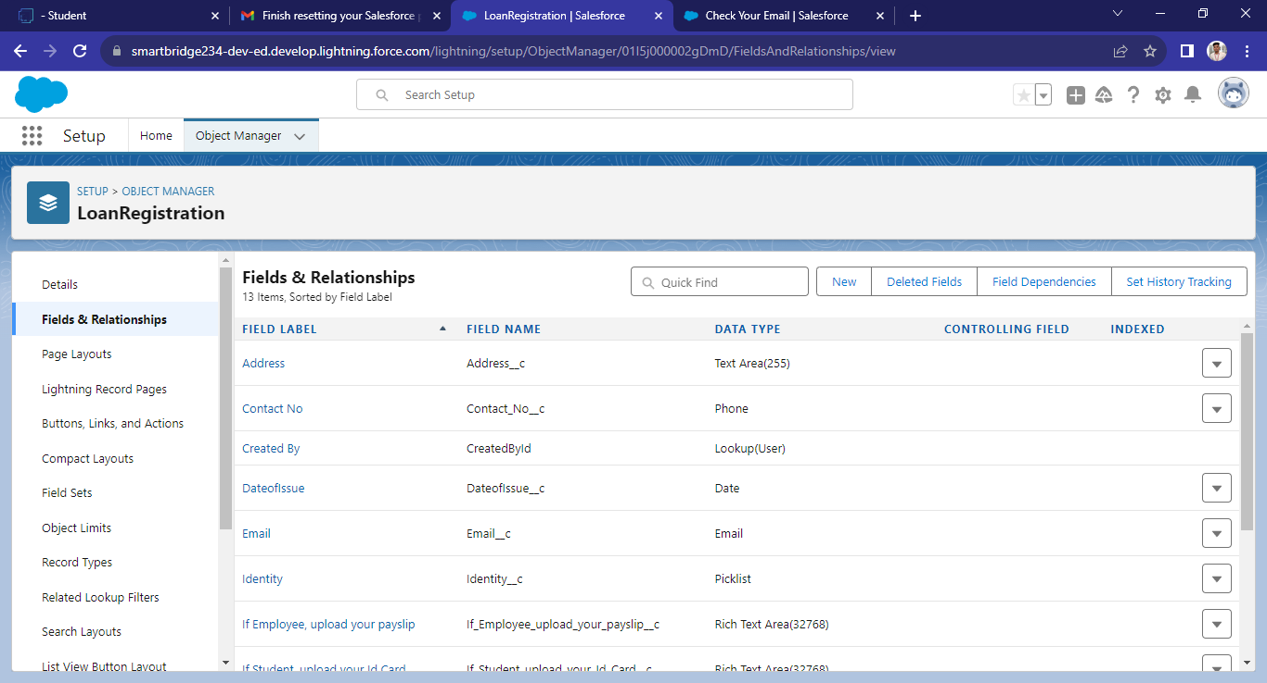

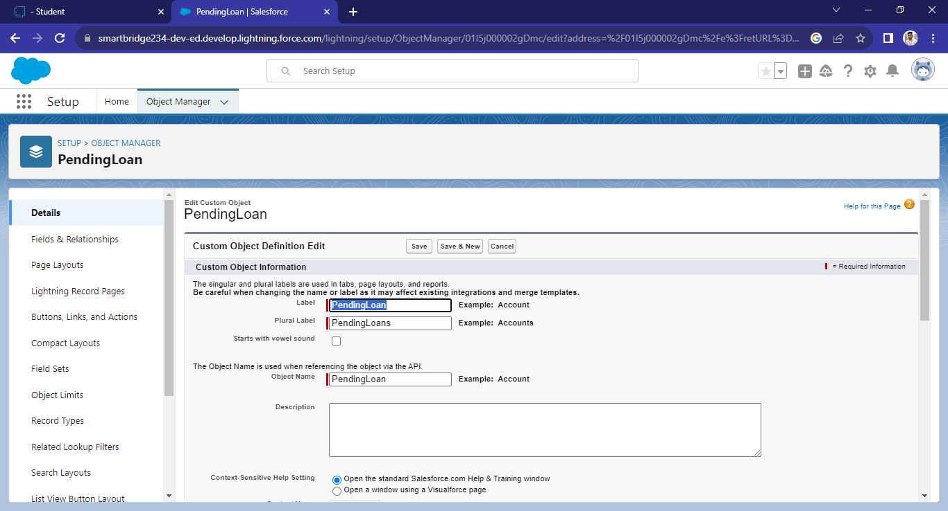

## Fields in Loan Clearance Object

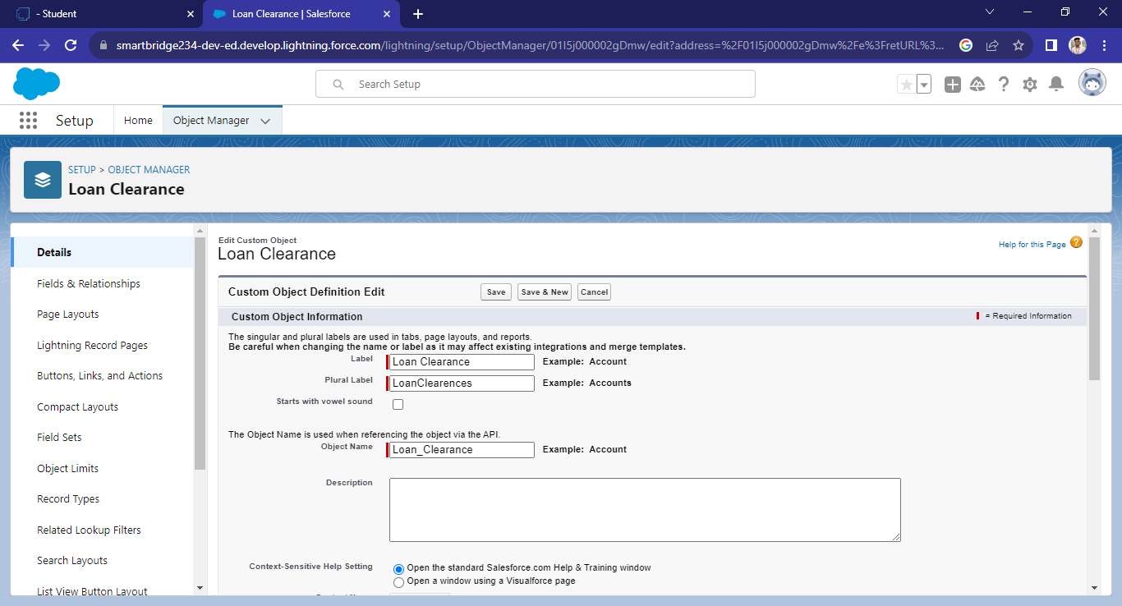

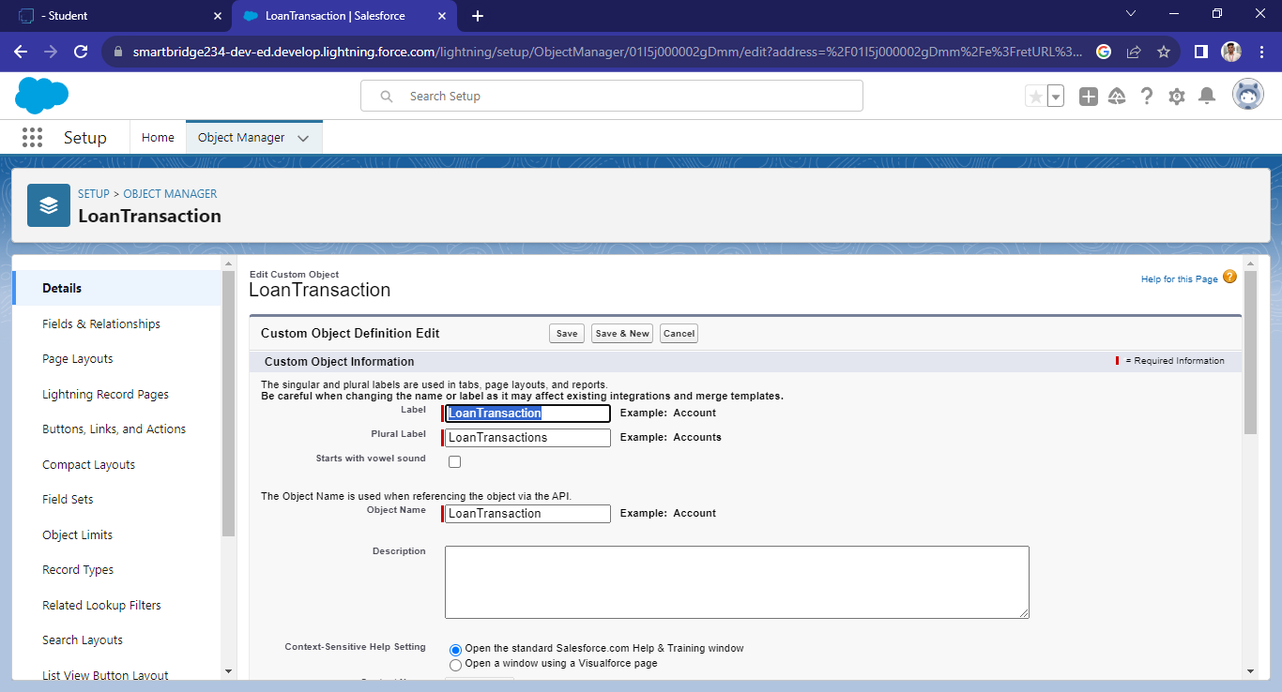

## Fields in Loan Transaction Object

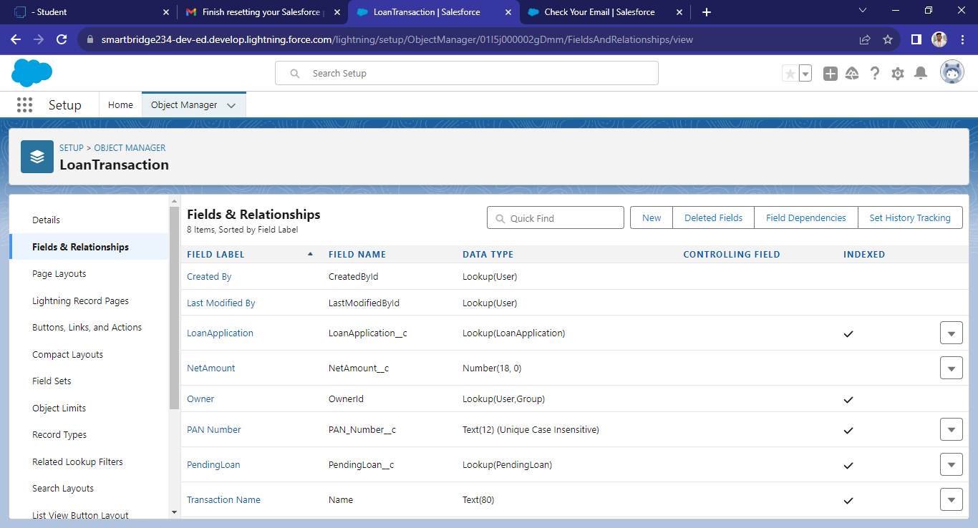



**Fields in Pending Loan Object**

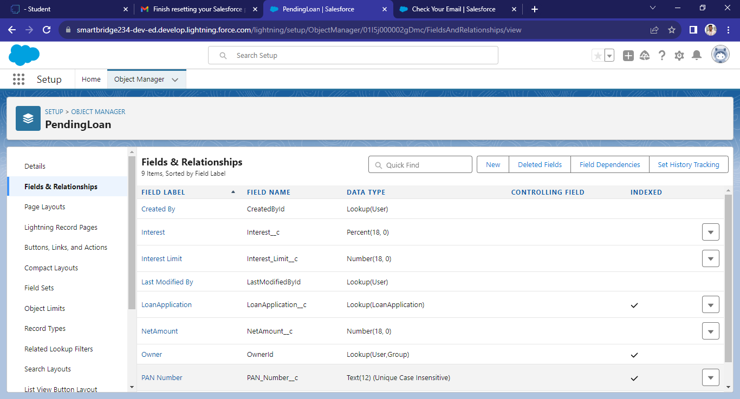

**Tabs**

Salesforce Tabs are like the menu options in a software application. They allow you to access specific functions, objects, or data.

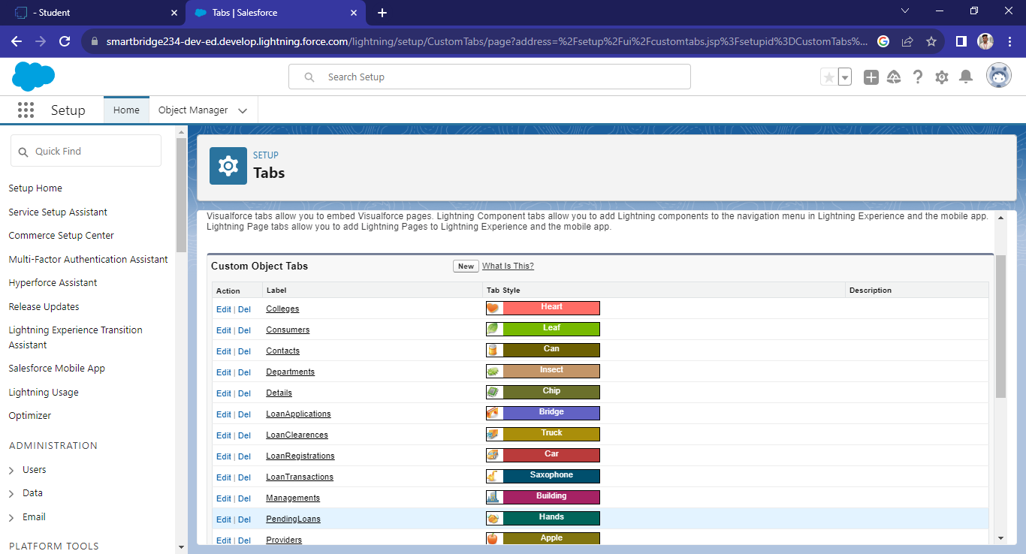

# Lightning App

The Lightning App Builder is a point-and-click tool that makes it easy to create custom pages for the Salesforce mobile app and Lightning Experience, giving your users what they need all in one place.

Create a Travel Approval Lightning App

* + - Build a Lightning app, add tabs, and customize page layouts.
    - Create custom objects and fields for the app.
    - Define relationships between objects.
    - Import data and test the app.

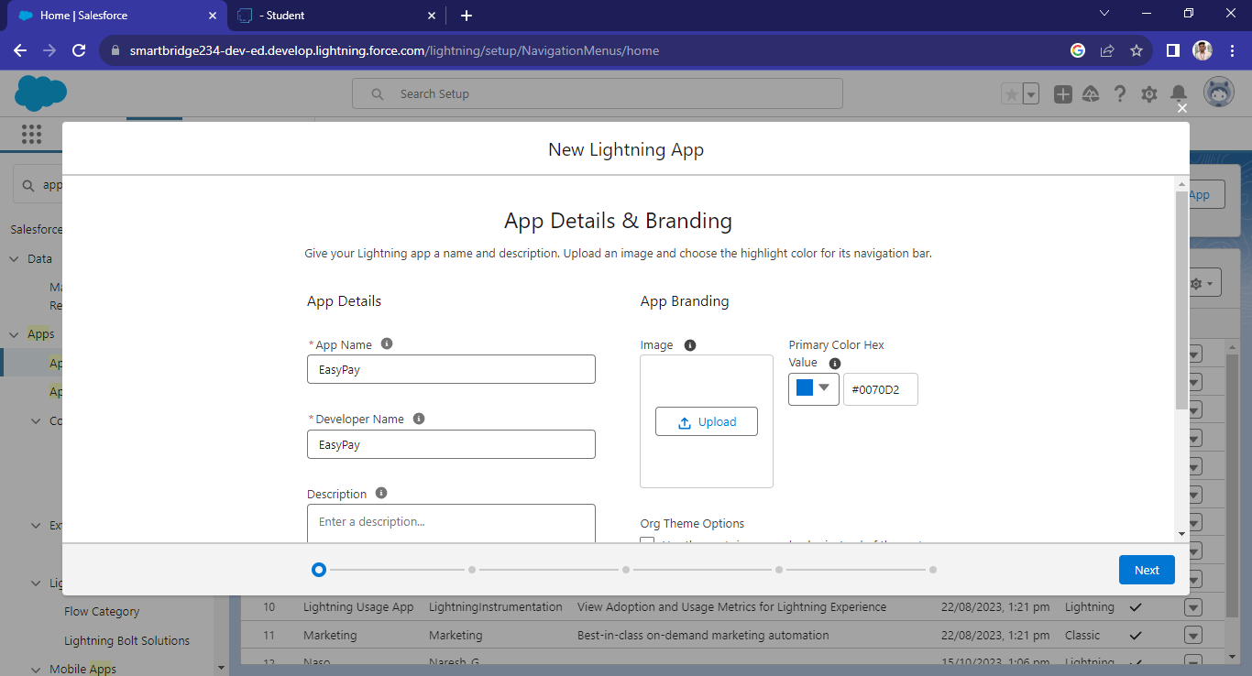

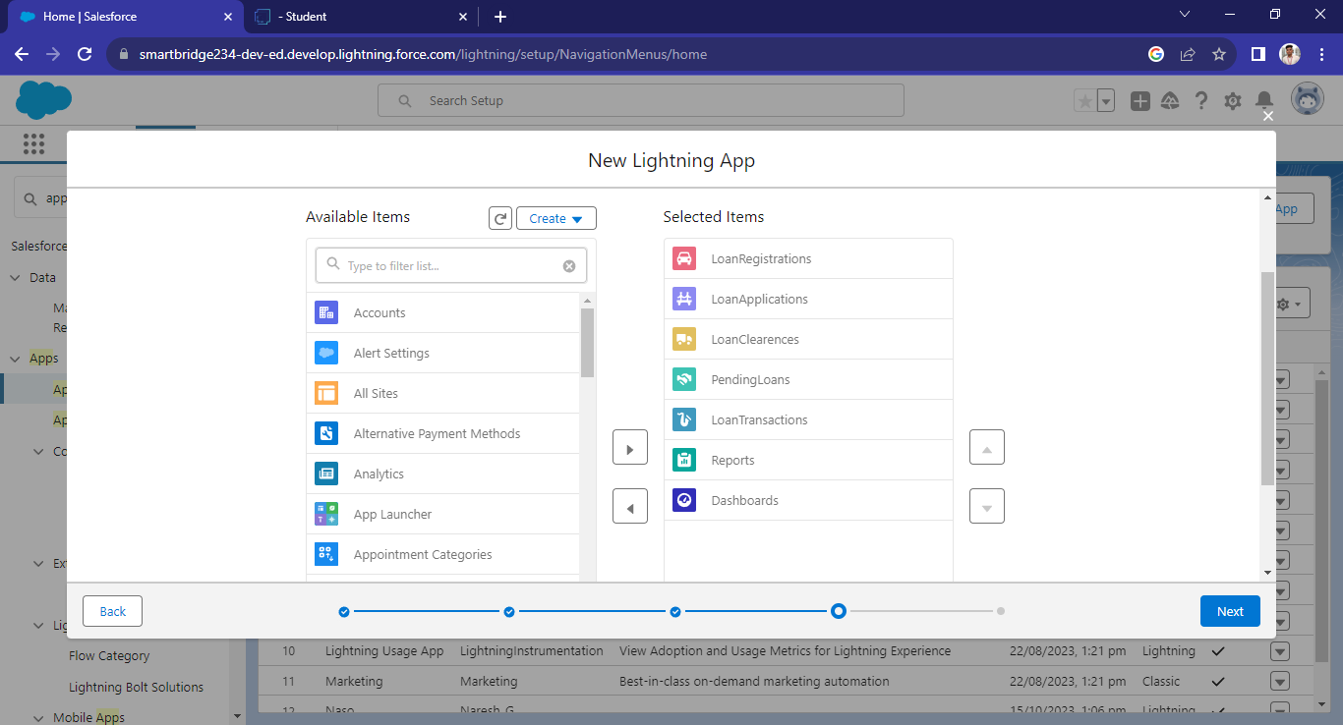

# CHAPTER-3 USERS AND DATA SECURITY

# Customize User Interface

Customize your app's page layouts, compact layouts, and actions.

## Page Layout

A page layout determines the fields, sections, related lists, and buttons that appear when users view or edit a record. You can modify an object’s default page layout or create a custom page layout.

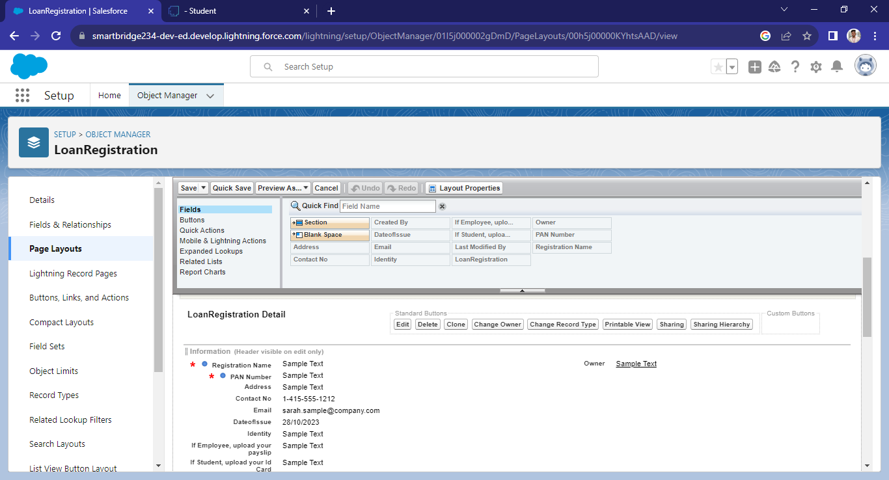

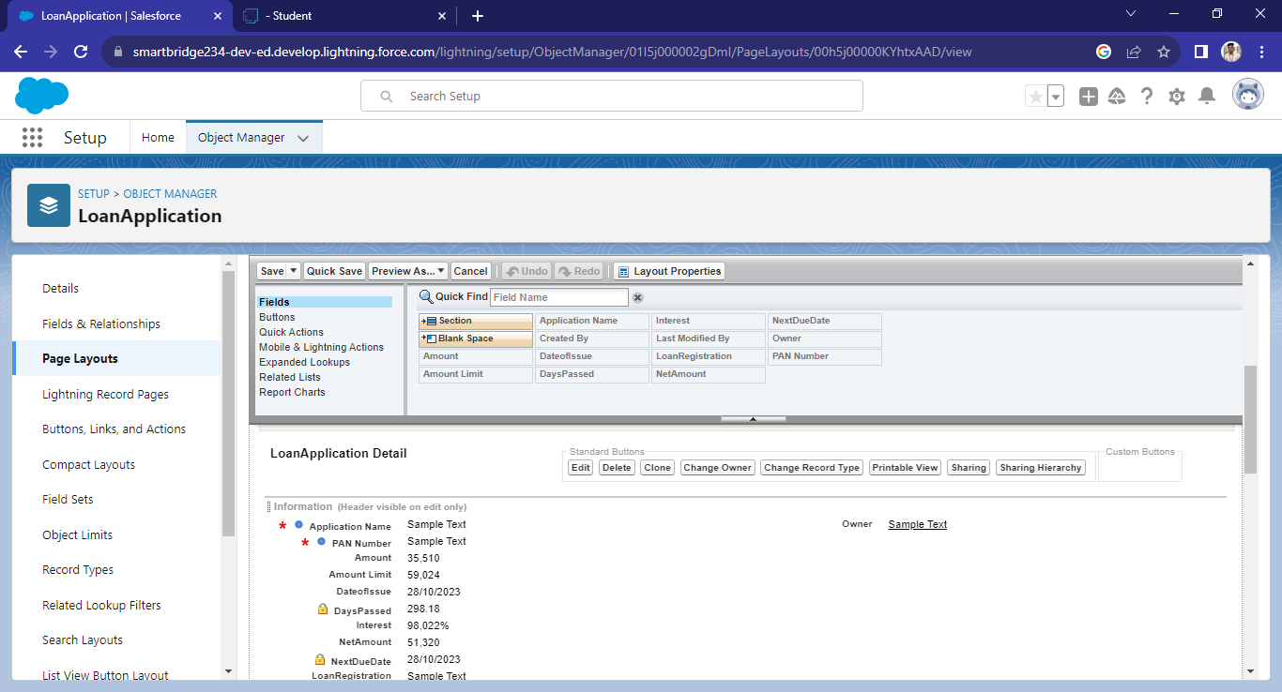

# CHAPTER-4 AUTOMATION

**4.1 Working Process And User Adaption:**

The working process and user adoption strategy are critical for the successful implementation of your CRM application for loan management and fraud prevention in Salesforce.

A well-planned working process and user adoption strategy are essential to ensure that the CRM application is effectively embraced by your organization and provides the intended benefits. User involvement, training, support, and continuous improvement efforts are key to a successful implementation.

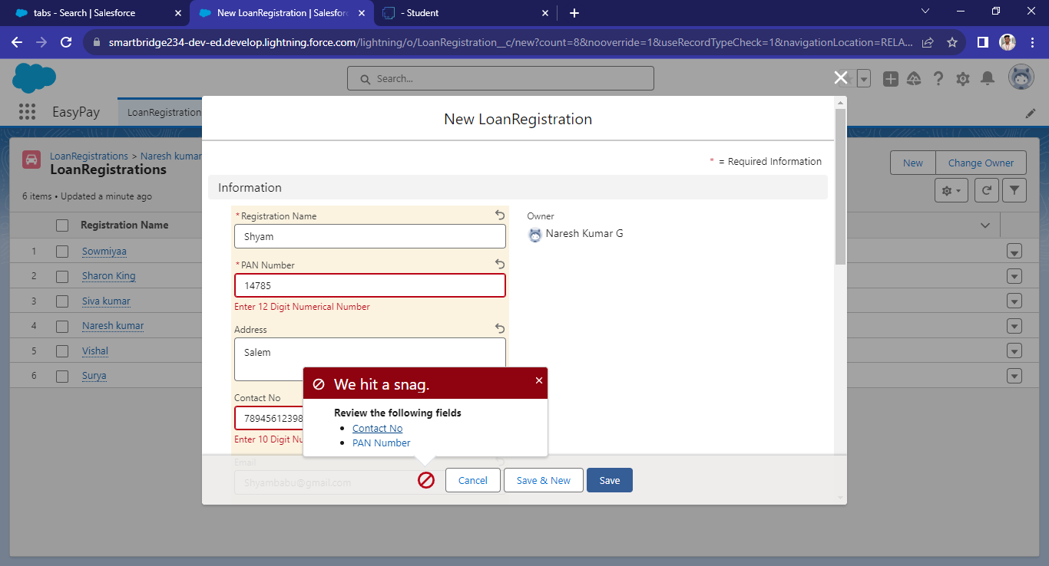

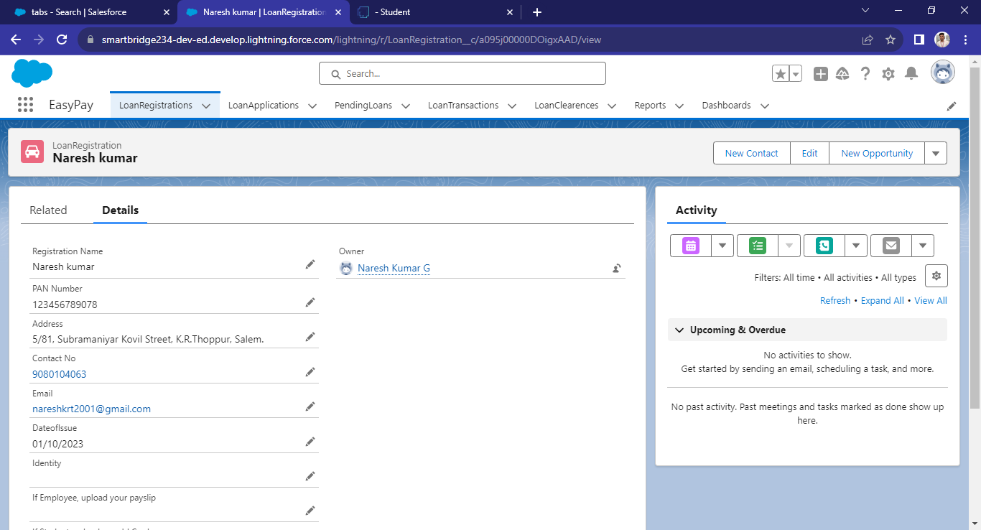

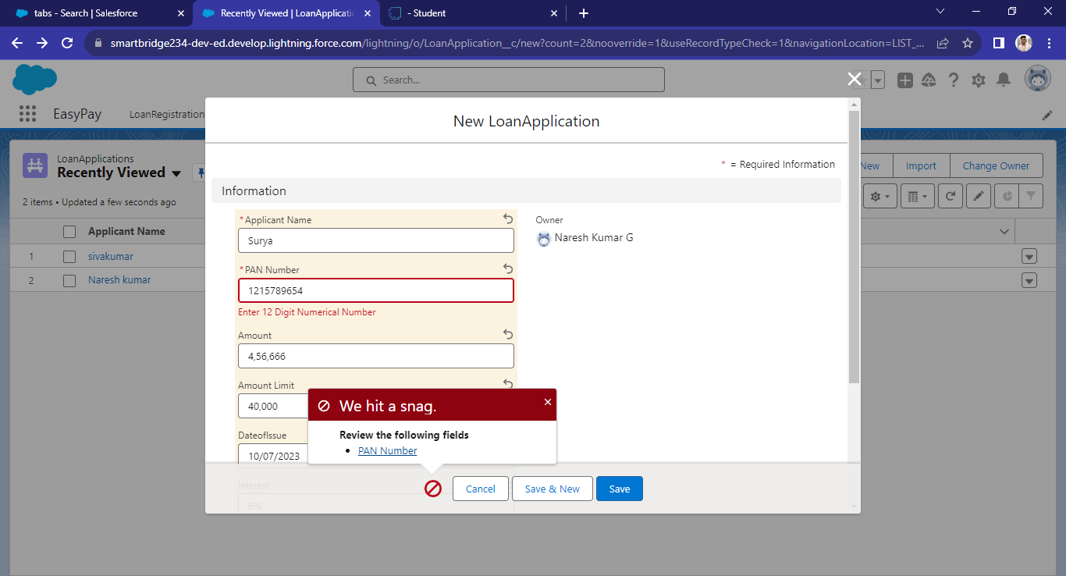

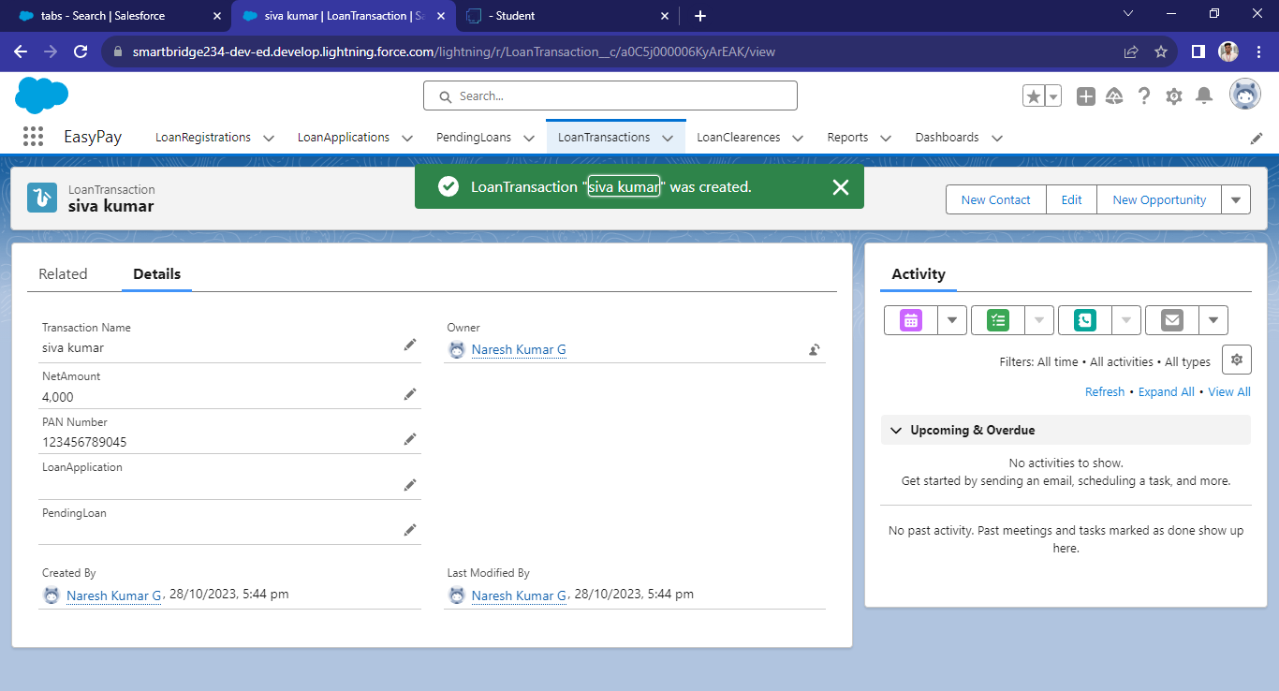

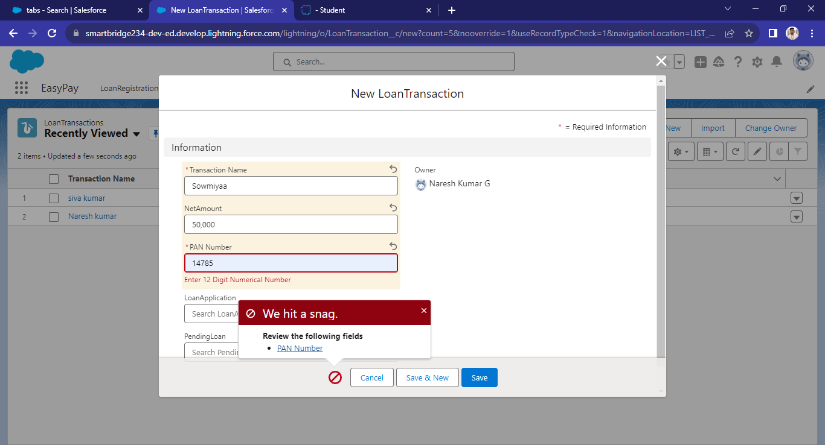

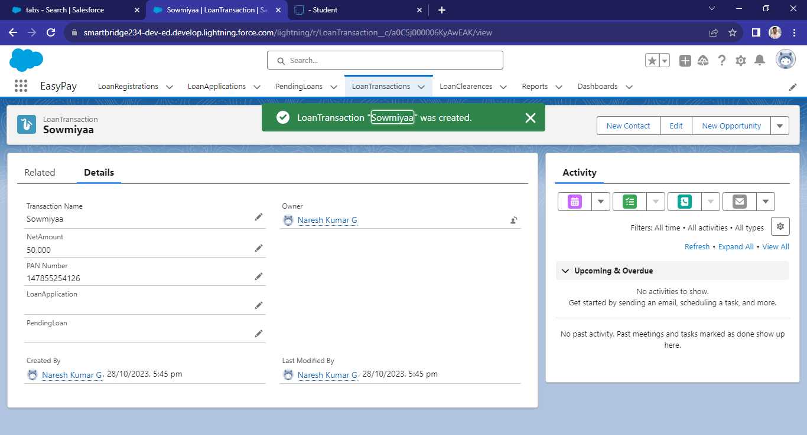

**4.2 APEX**

Apex is a strongly typed, object-oriented programming language that allows developers to execute flow and transaction control statements on the Lightning platform server in conjunction with calls to the Lightning Platform? API. Using syntax that looks like Java and acts like database stored procedures, Apex enables developers to add business logic to most system events, including button clicks, related record updates, and Visualforce pages. Apex code can be initiated by Web service requests and from triggers on objects.

## Creating Classes :

Apex classes are modeled on their counterparts in Java. You’ll define, instantiate, and extend classes, and you’ll work with interfaces, Apex class versions, properties, and other related class concepts.

**Class:**  
 As in Java, you can create classes in Apex. A class is a template or blueprint from which objects are created. An object is an instance of a class.

**Object:**

Object is an instance of a class, where it can access all the properties that are present in a class i.e variables and methods.

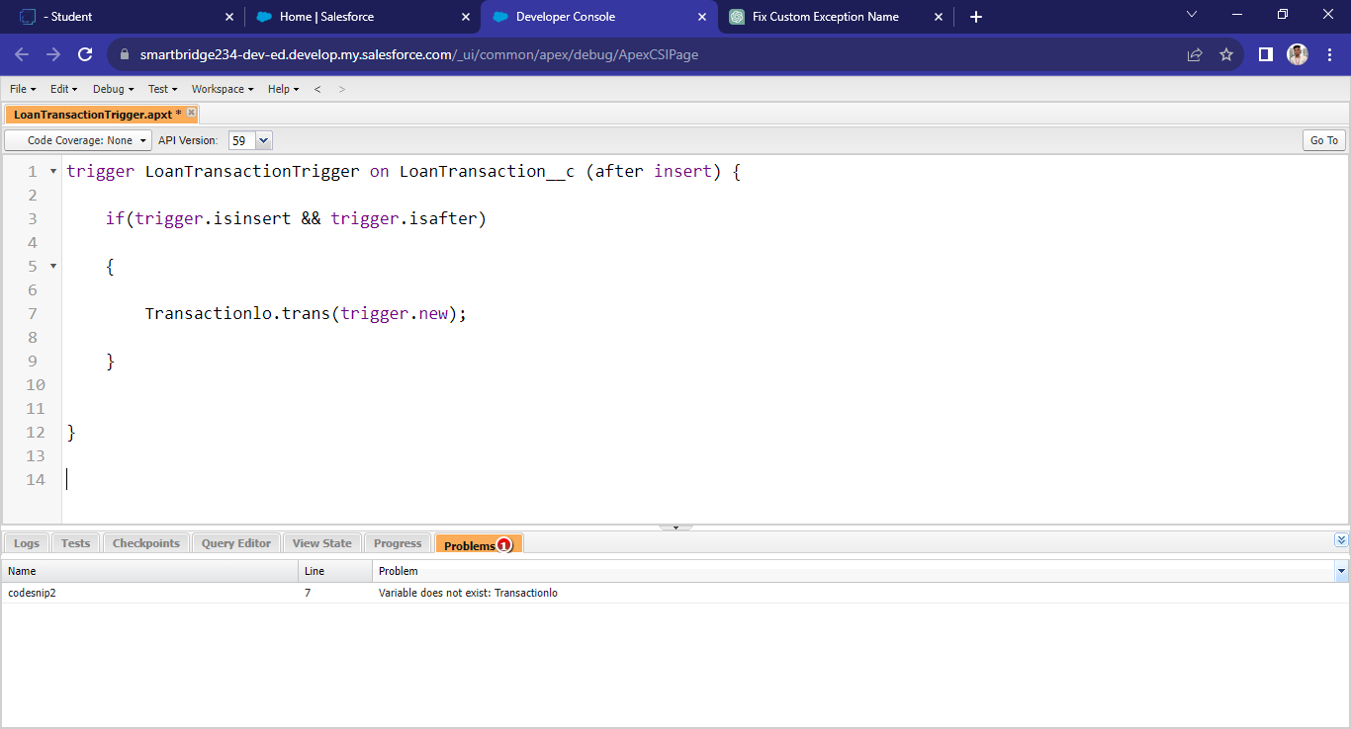

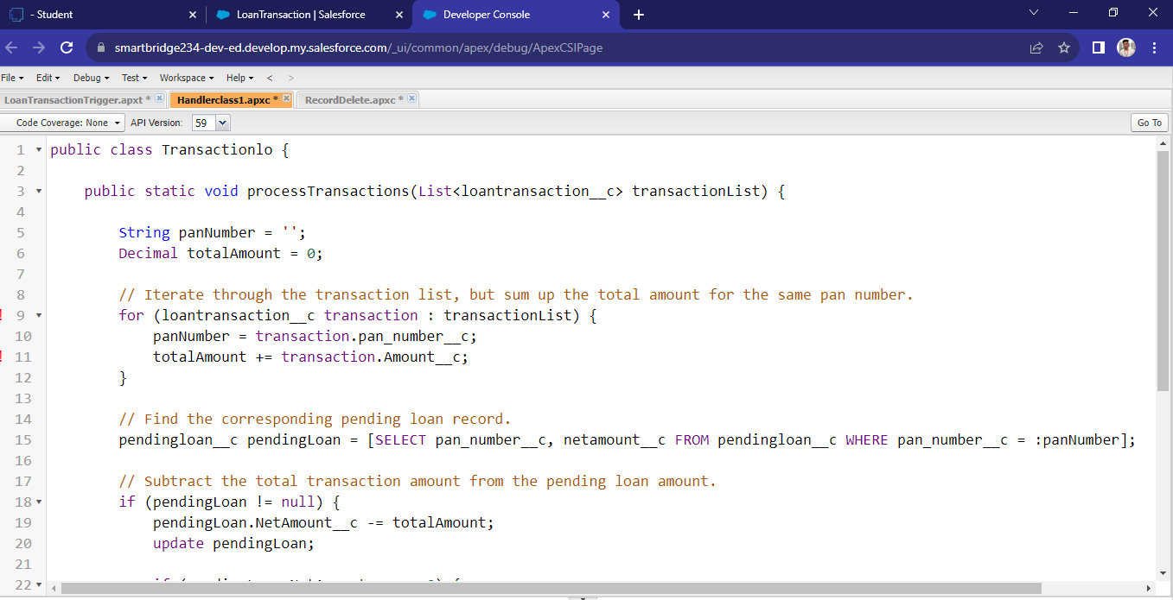

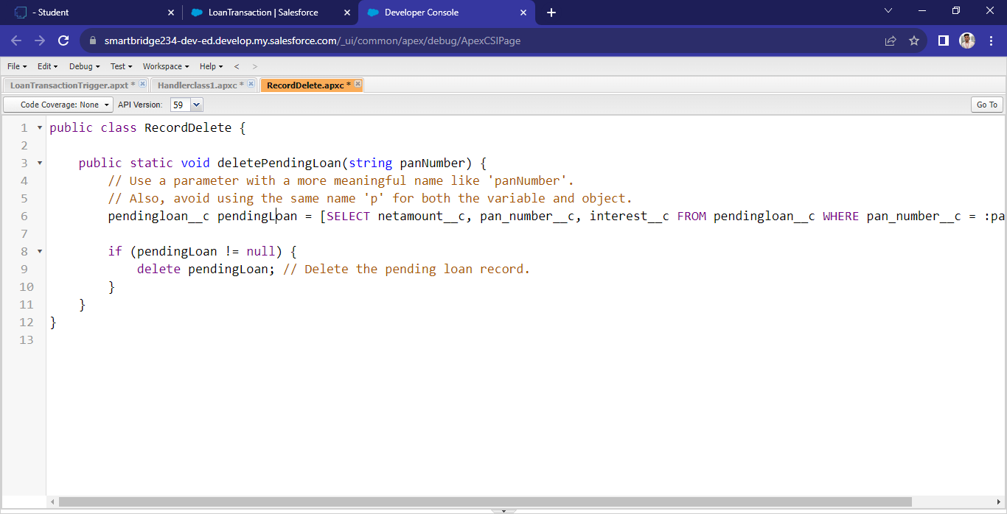

**4.3 APEX SCHEDULER**

The Apex Scheduler lets you delay execution so that you can run Apex classes at a specified time. This is ideal for daily or weekly maintenance tasks using Batch Apex. To take advantage of the scheduler, write an Apex class that implements the Schedulable interface, and then schedule it for execution on a specific schedule.

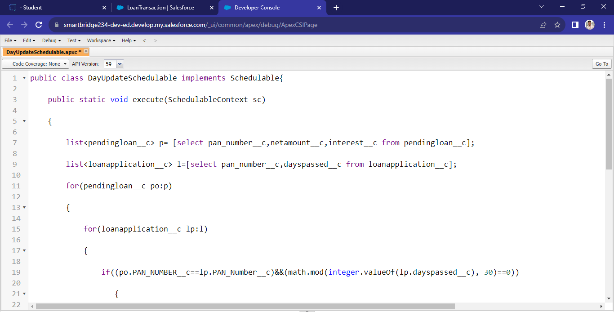

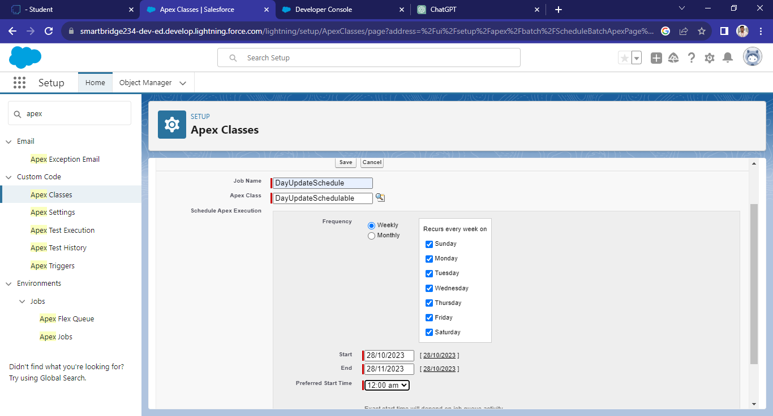

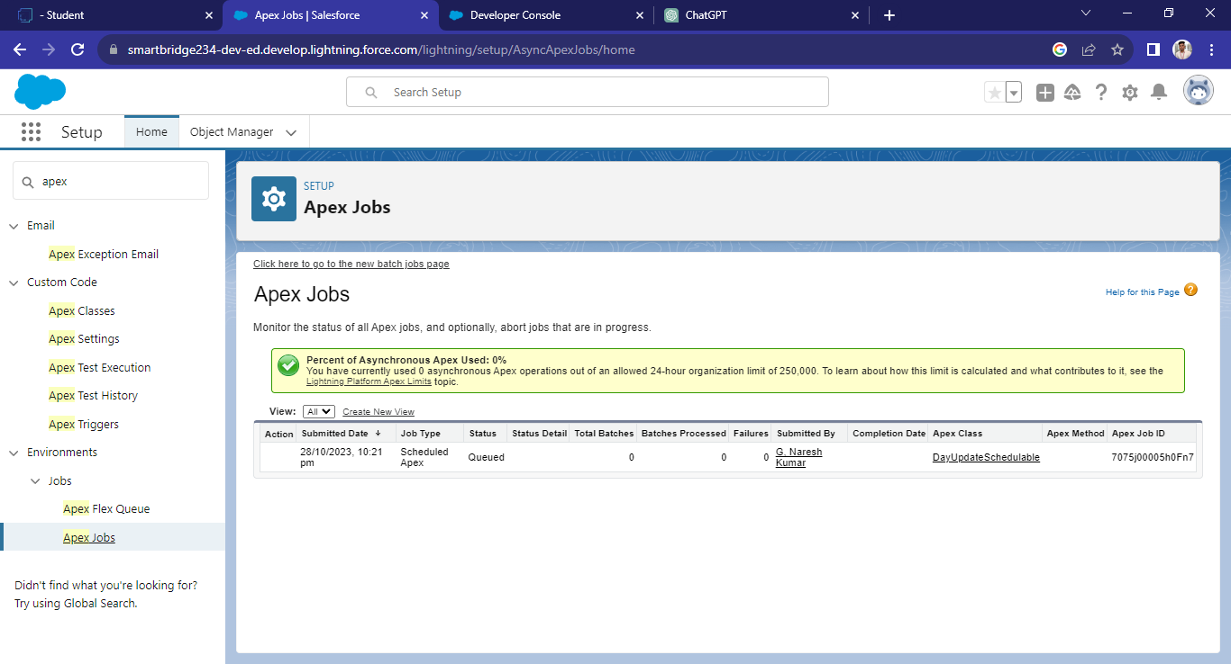

**CHAPTER-5 REPORTS & DASHBOARD**

# Reports

A Salesforce report is a list of data generated based on filter criteria. Salesforce Reports helped us predict trends and gives us the advantage to increase profits.

The report builder provides a drag-and-drop interface to easily build and customize your reports.

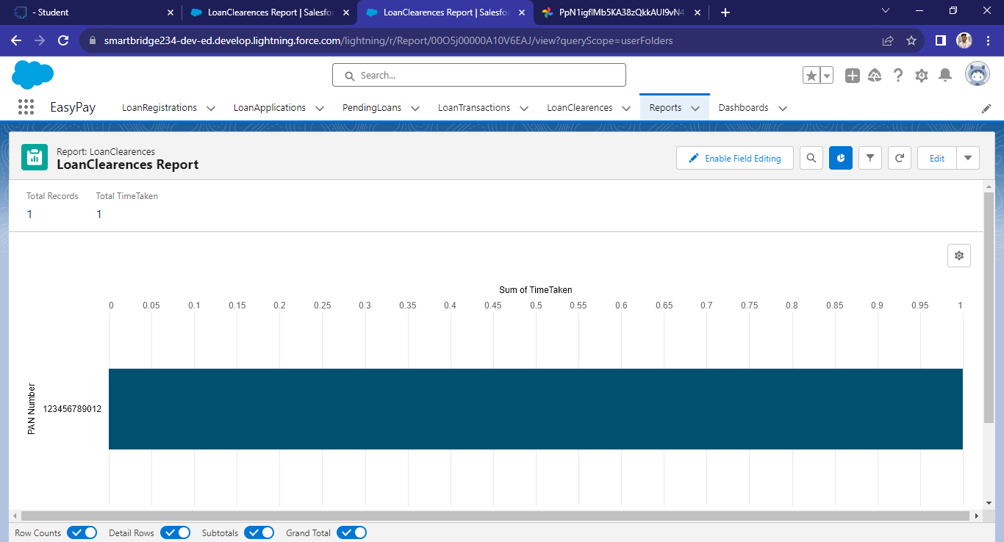

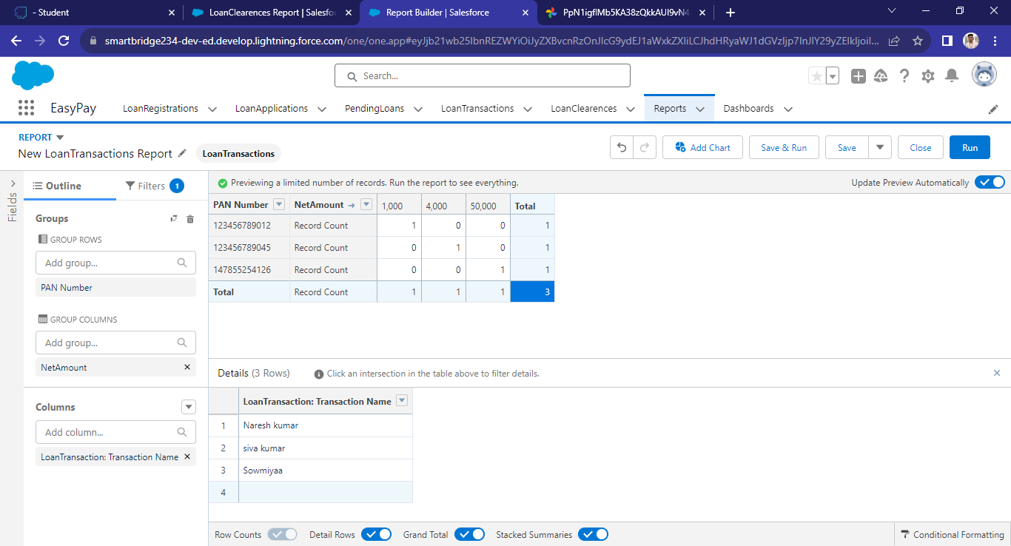

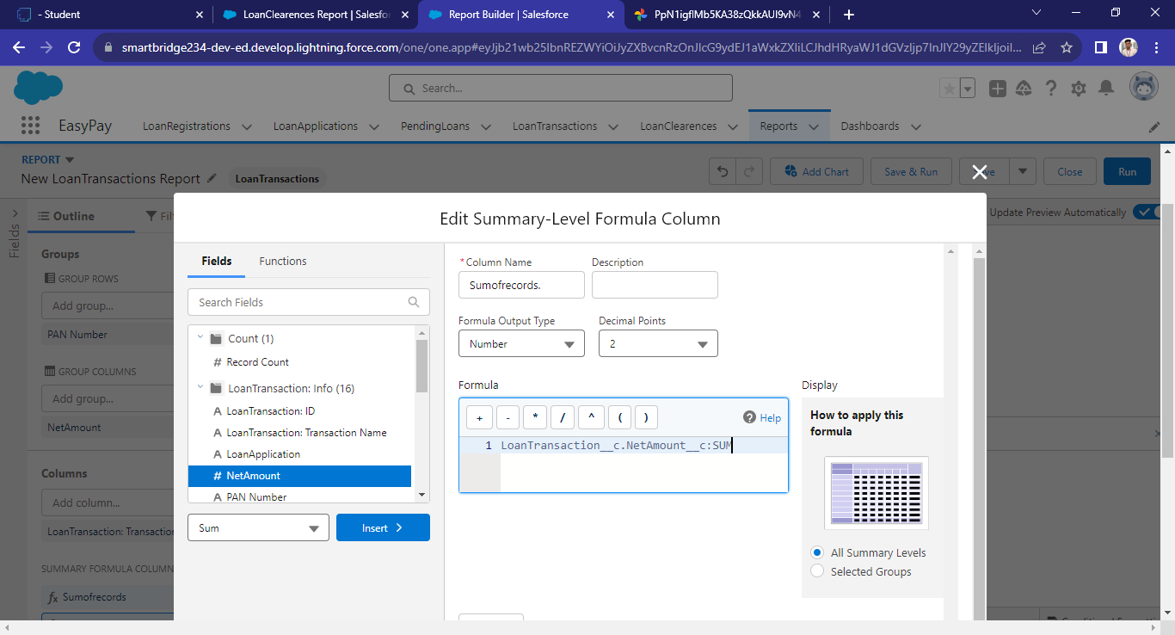

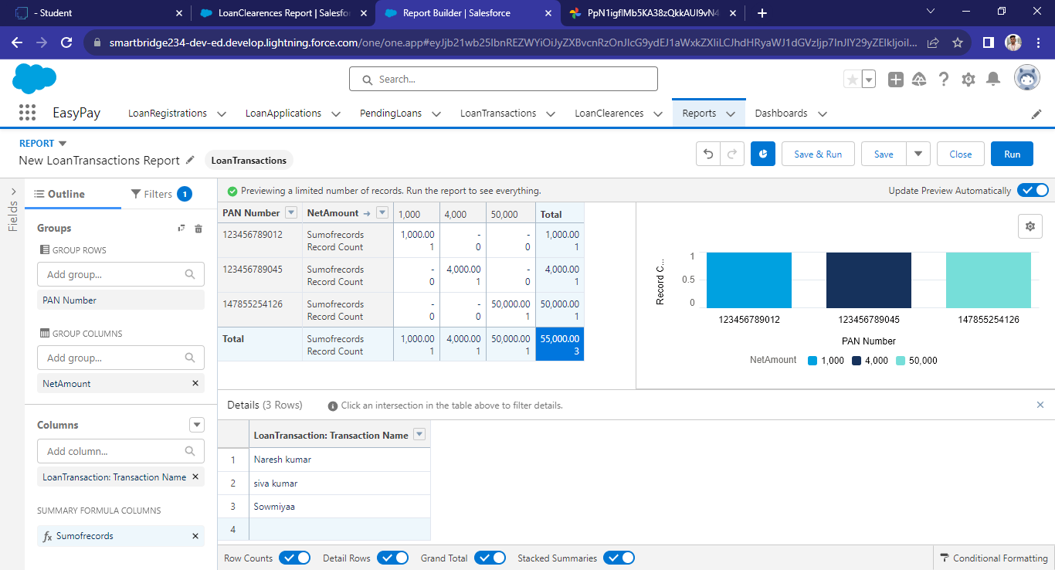

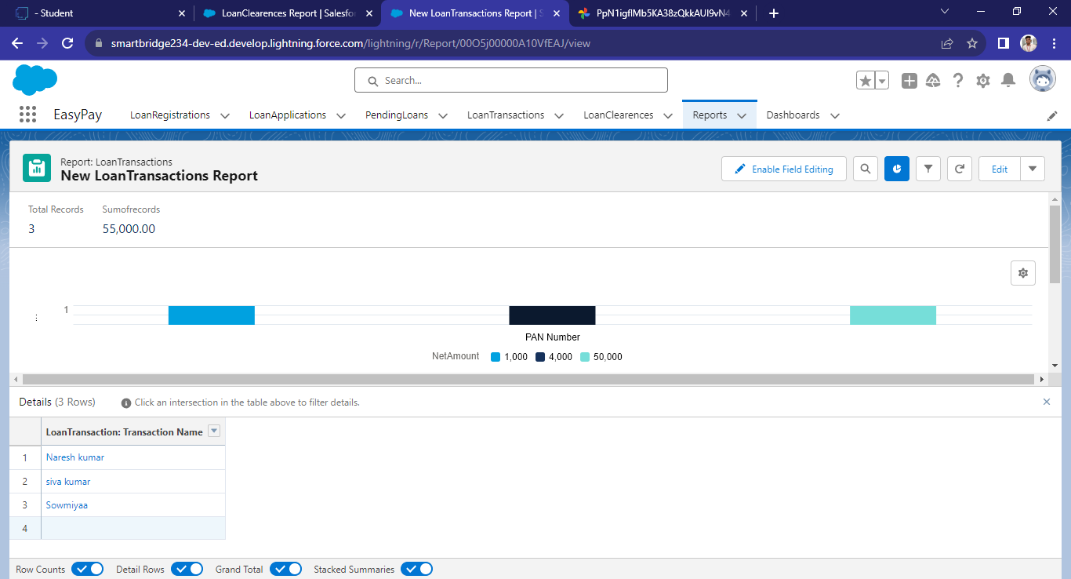

# Dashboard

A dashboard provides an interactive visual display of key metrics and trends. Multiple dashboard components can be shown together on a single dashboard layout, creating rich visual displays of multiple reports that have a common theme.

Dashboards help you visually understand changing business conditions so you can make decisions based on the real-time data you’ve gathered with reports. Use dashboards to help users identify trends, sort out quantities, and measure the impact of their activities

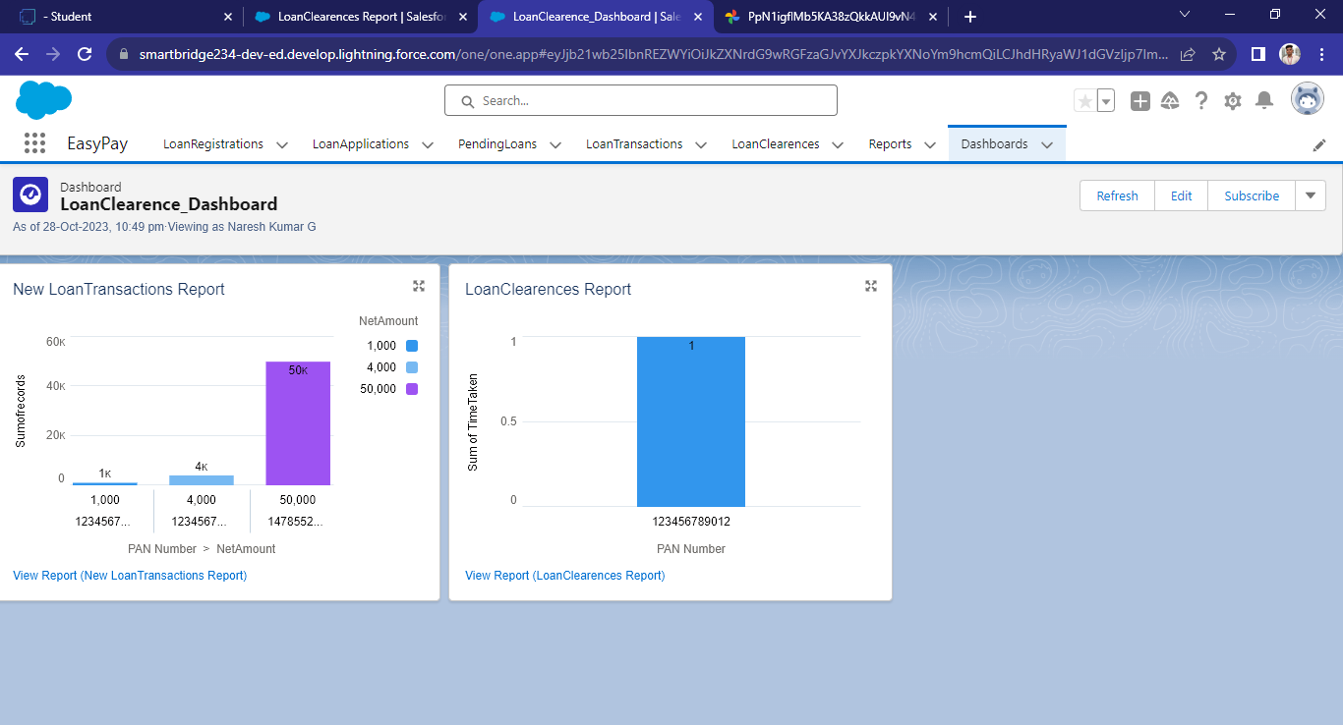

# CHAPTER-6 CONCLUSION

In conclusion, the development of a Salesforce-based CRM application for loan management and fraud prevention represents a transformative step toward improving efficiency, security, and customer satisfaction within our organization. By streamlining loan application processes, enhancing fraud prevention measures, and focusing on user adoption, we aim to address critical challenges while fostering growth and trust.

The integration of advanced technology, such as AI-driven fraud detection and real-time credit scoring, into the robust Salesforce platform, creates a unique and innovative solution. This application not only simplifies loan processes but also safeguards our institution and customers against fraudulent activities, supporting financial well-being in our community.

The technical requirements, encompassing data security, compliance, scalability, and performance optimization, underpin the foundation of our CRM system. Additionally, the working process and user adoption strategy emphasize the importance of involving users, providing comprehensive training, and continuous improvement for the successful adoption of the system.

As we move forward, our commitment to effective change management, user empowerment, and a user-centric design approach will guide us toward a successful implementation. We anticipate that this CRM application will drive not only operational excellence but also enhanced customer experiences, ensuring our institution's continued success in the dynamic financial landscape. We are excited about the positive impact it will have on our organization, employees, and valued customers.

# CHAPTER-7

# PROJECT DEMONSTRATION

**Github:**

<https://github.com/Nareshkumar2001/Naan-Mudhalvan-Salesforce>

**Demo Link:**

<https://drive.google.com/file/d/1DMvfWBkOkIARvoXrFbEXvl64bRQncRhz/view?usp=sharing>

**Trailhead Link:**

NARESH KUMAR G (620120104068) - <https://www.salesforce.com/trailblazer/nareshkumarg>

SHYAMBABU S (620120104090) - <https://www.salesforce.com/trailblazer/shyambabusxvmi8usb0g90>

SURYS S (620120104315) - <https://www.salesforce.com/trailblazer/suryaska6to0juosxb>

YUVARAJ S (620120104320) - <https://www.salesforce.com/trailblazer/yuvarajs492xq2sh6s2u>